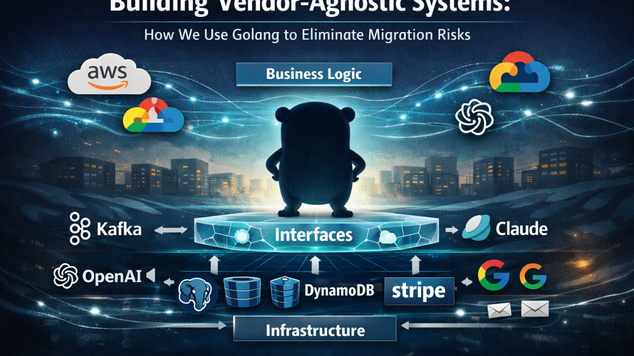

Building Vendor-Agnostic Systems: How We Use Golang to Eliminate Migration Risks



Aunmoy Dey

Backend Engineer | Go, Kubernetes & Distributed Systems | Architecting AI-Native Infrastructures & Event-Driven SaaS
May 16, 2026

Most Developers learn SOLID principles just to pass interviews. But in real-world production environments, the Dependency Inversion Principle (DIP) is what keeps an entire architecture from collapsing when technologies inevitably shift.
In 2026, tech stacks evolve faster than ever. Systems are constantly switching between:
- LLMs: OpenAI → Claude → Gemini
- Message Brokers: Kafka → RabbitMQ
- Databases: PostgreSQL → DynamoDB
- Cloud Providers: AWS → GCP
When these shifts happen, does your team rewrite the entire core application, or do they just swap a package? That is the DIP litmus test.
Here is a practical guide to mastering Dependency Inversion in Golang, written for engineers who want to design resilient systems.

🧠 The Mental Model: "What" vs. "How"
To understand DIP, you must first clearly distinguish between High-Level and Low-Level modules.
Imagine building an app like Uber.
- High-Level Modules (The "What"): Matching riders, calculating fares, tracking rides. These are pure business rules. This is the entire reason the company exists.
- Low-Level Modules (The "How"): Google Maps API, Stripe SDK, Kafka, Redis. These are just implementation tools.
The Senior Architect's Golden Rule: If replacing a component changes the core business meaning, it is High-Level. If replacing it only changes the implementation details, it is Low-Level.
DIP dictates that high-level business logic must never depend on low-level infrastructure. Both must depend on abstractions.

The Junior Mistake: Tight Coupling
Consider this common anti-pattern in Go:
package shipment

import "github.com/openai/openai-go"

type ShipmentService struct {
client *openai.Client // ❌ Direct dependency on infrastructure
}
This looks harmless at first glance. However, your core business layer is now tightly bound to the OpenAI SDK, its specific authentication models, and its API payloads.
If OpenAI changes its SDK breaking compatibility, or if your team decides to migrate to Claude, your core business service breaks and must be completely rewritten.

💡 The Go Way: Consumer-Driven Interfaces
Go handles DIP elegantly because interfaces are satisfied implicitly. You don't explicitly declare that a struct implements an interface; it just happens if the methods match.
This enables a massive architectural advantage: The Consumer-Driven Interface. The business layer defines exactly what it needs, and the infrastructure layer adapts to it.

Step 1 — The Business Defines the Contract
package shipment

import "context"

// The Business Contract (The "What")
type Summarizer interface {
Summarize(ctx context.Context, text string) (string, error)
}

type ShipmentService struct {
summarizer Summarizer
}

func NewShipmentService(s Summarizer) *ShipmentService {
return &ShipmentService{summarizer: s}
}

func (s *ShipmentService) GenerateShipmentInsight(ctx context.Context, text string) (string, error) {
// The business logic doesn't care about OpenAI or Claude. It just wants a summary.
return s.summarizer.Summarize(ctx, text)
}
Notice something critical.
The business logic says:
“I need text summarized.”
It does NOT say:
- OpenAI
- Claude
- HTTP
- REST
- SDK
- JSON
That separation is the entire point.

Step 2: Infrastructure Adapts to the Contract
package openaiimpl

import (
"context"
"github.com/openai/openai-go"
)

type OpenAISummarizer struct {
client *openai.Client
}

// Implicitly satisfies the shipment.Summarizer interface
func (o *OpenAISummarizer) Summarize(ctx context.Context, text string) (string, error) {
resp, err := o.client.Chat.Completions.New(...)
if err != nil {
return "", err
}
return resp.Choices[0].Message.Content, nil
}
Now the dependency direction is inverted.
Before:
ShipmentService ───> OpenAI SDK
After:
ShipmentService ───> Summarizer Interface <─── OpenAI Implementation
Now:
- business logic is stable
- infrastructure becomes replaceable
- vendor churn becomes manageable
This is Dependency Inversion.

The Senior Go Engineering Insight
One of the most important Go architecture patterns is:
Consumer-Driven Interfaces
In many languages, interfaces are placed beside implementations.
In Go, the consumer owns the interface.
Why?
Because the business layer defines what it needs.
The infrastructure layer adapts to the business — not the other way around.
This is one of the cleanest architectural advantages Go provides.

Why DIP Becomes Critical in Modern Systems
DIP matters massively when:
- AI providers change
- payment gateways change
- cloud vendors change
- databases migrate
- message brokers change
- external APIs evolve
Without DIP:
- infrastructure leaks into business logic
- migrations become expensive
- testing becomes painful
- architecture becomes rigid
With DIP:
- systems become resilient
- implementations become swappable
- testing becomes simple
- scaling becomes easier

Production-Level Patterns Enabled by DIP

1. Multi-LLM Failover (True Resilience)
Because the business layer relies purely on an abstraction, you can implement resilient structural wrappers without touching your business logic:
type FailoverAIAdapter struct {
primary shipment.Summarizer
secondary shipment.Summarizer
}

func (f *FailoverAIAdapter) Summarize(ctx context.Context, text string) (string, error) {
res, err := f.primary.Summarize(ctx, text)
if err != nil {
// Transparent failover if the primary provider hits rate limits or outages
return f.secondary.Summarize(ctx, text)
}
return res, nil
}
Now your business logic remains untouched while:
- providers fail
- rate limits happen
- outages occur
- costs change
That is real architectural flexibility.

Another Senior-Level Insight: Prevent Data Leakage
A common architectural mistake:
Passing:
- GORM models
- SQL structs
- external API responses
directly into business services.
That leaks infrastructure details into the domain.
The rule is:
Infrastructure models must be mapped into clean domain entities before crossing boundaries.

2. Preventing Data Leakage
A common architectural pitfall is passing GORM models, raw SQL structs, or direct third-party API payloads straight into business logic. This leaks low-level infrastructure details into your domain.
Always map infrastructure models into clean, independent Domain Entities before they cross boundaries into your business logic.

3. Beautiful, Ultra-Fast Unit Testing
Testing code that depends directly on external databases or APIs is slow and flaky. With DIP, mocking becomes beautifully trivial:
type MockSummarizer func(text string) (string, error)

func (m MockSummarizer) Summarize(ctx context.Context, text string) (string, error) {
return m(text)
}
Now tests:
- avoid real APIs
- avoid databases
- avoid flaky network calls
- run fast in-memory
This is one reason senior Go systems stay maintainable at scale.

The Ultimate Mental Model
Your company does NOT exist to:
- serialize JSON
- call SDKs
- structure SQL queries
- manage HTTP payloads
Those are tools.
Your company exists to solve business problems.
The tools must serve the architecture.
The architecture must never surrender to the tools.
#golang #softwareengineering #systemdesign #cleanarchitecture #microservices #backend #distributedsystems #solidprinciples #ai #programming

